**CHAPTER 1**

**INTRODUCTION**

* 1. **PROBLEM STATEMENT**

XYZ is a courier company. As we appreciate that human capital plays an important role in collection, transportation and delivery. The company is passing through genuine issue of Absenteeism. The company has shared it dataset and requested to have an answer on the following areas:

1. What changes company should bring to reduce the number of absenteeism?

2. How much losses every month can we project in 2011 if same trend of absenteeism continues?

**1.2 DATA**

Our task is to determine the target variable (Absenteeism time in hours) which is a numerical variable. Thus , we will apply different regression models and choose the best out of them. 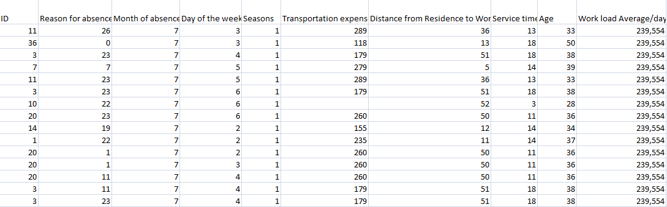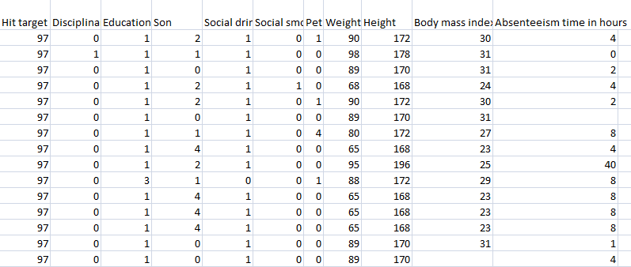

Table 1.1 and 1.2 contain all the variables for the Absenteeism at work dataset.

**CHAPTER 2**

**Methodology**

**2.1 Pre Processing**

**1) Sorting –** For the project to be better comprehensive, the dataset is first

sorted in the order of “ID” and then in the order of “Reason for absence” i:e 2 level sorting is done.

**2) Conversion –** The variables are converted into suitable data types i:e either categoricalor numerical. Out of the 21 variables, 10 are taken as categorical and the rest 11 as numerical.

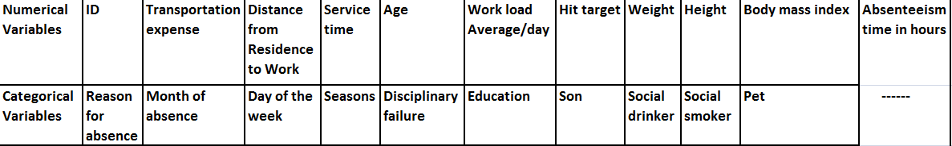

**2) Missing Value Analysis –** Next step is to impute the missing values. Out of the 3

ways of mean, median and KNN imputation, the KNN method is the most accurate. Thus it is adopted.

**2.2 Outlier Analysis**

Outlier analysis is used to remove the messy data points which are beyond the maximum and the minimum values of the variable. For determining the outliers, boxplots come in handy. On analysis the given dataset, the outlier analysis should be applied to 3 numerical variables which are “Work load Average/day”, “Hit target” and “Absenteeism time in hours”. Rest all numerical variables have uniform values according to the “ID” and thus any outlier in those numerical variables would occur merely due to the different frequencies of different ID numbers. On the other hand, the 3 variables listed above hold different values according to different IDs.

Once the outliers in the 3 variables are determined, they are then replaced with NA. Then those NA values are imputed using KNN imputation.

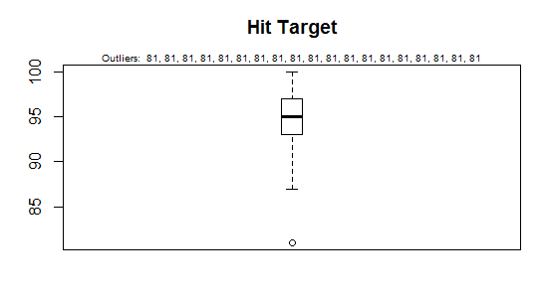

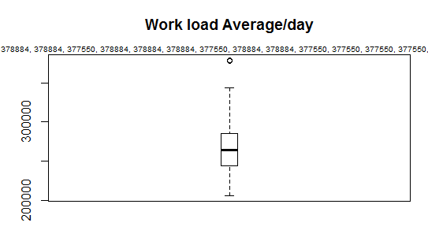

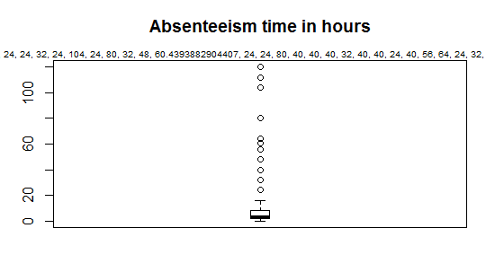

**2.3 Feature Selection**

Before performing any type of modeling we need to assess the importance of each predictor variable in our analysis. There is a probability that many variables in our analysis are not important at all. We have used Correlation plots to eliminate the features.

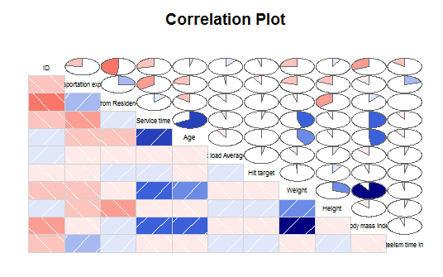

The “weight” and “Body mass Index” variables have high correlation. Thus, out of them, “Body mass Index” is removed.

**2.4 Feature Scaling**

Feature scaling is implemented for all the numerical variables to be in the same range and thus the magnitude of any particular variable doesn’t hamper the model results. Feature scaling in the code is done on all numerical variables except “ID” as it is used as a reference variable.

**CHAPTER 3**

**Modeling**

I tried using decision tree and regression models. Both the models gave fairly high accuracy(>85%) . So, on the basis of adjusted R-square value linear regression method was used after removing multicollinear elements with VIF >8.

On the basis of the model developed, following are the answers of the problems given in the dataset :-

1. Company needs to make several changes to bring down the absenteeism cases. These changes are made on the basis of the degree of dependence of the absenteeism variable on other variables. Some of them include :-
2. ID – It has high dependence on absenteeism. Thus, IDs with high frequency of leaves need to be removed from thee organization.

The threshold for same is chosen as 40days. Thus, on that basis ID numbers 3,20,22,28,34 need to be removed.

1. Reasons for absence – Some reasons impact the absenteeism highly while others to moderate level. For e:g, absenteeism rate shows high dependence on Reason 9 (circulatory system) and thus these need to be taken care of by providing proper healthcare to the employees. Other such reason of absences are Reason 19 and Reason 22.
2. Distance from Residence to Work – It also affects the absenteeism rate highly. The threshold for the same is taken as 25km and thus for the employees having distance from work >25km suitable arrangements need to be made.
3. Apart from them Service time and Age are also important factors but they have been removed due to multicollinearity issues.
4. For predicting the absenteeism time every month, the model was sorted according to the “month of absence” variable. Then the sum for absenteeism time for that month was calculated. As, the dataset is normalized, it was then converted back to it’s original range(0,16), by multiplying the sum of normalized hours by 16.

|  |  |
| --- | --- |
| Month of absence | Absenteeism time in hours |
| 1 | 193.04 |
| 2 | 258.83 |
| 3 | 402.16 |
| 4 | 231.89 |
| 5 | 283.77 |
| 6 | 244.83 |
| 7 | 379.4 |
| 8 | 232.03 |
| 9 | 181.15 |
| 10 | 287.76 |
| 11 | 280.8 |
| 12 | 208.59 |